2152118 史君宝 编译原理 第四章作业

第一题

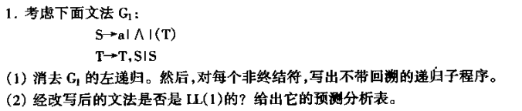

（1）解答：

首先消除左递归，S没有问题，不用改，仍为S->a|∧|(T)

但是T中存在左递归，需要改变，可以改为：

T->ST’ T’->,ST’|ε

综上，可以改为：S->a|∧|(T)

T->ST’

T’->,ST’|ε

递归子程序：

P(S);

Begin

if ch==’a’ or ch ==‘∧’

then next

else if ch == ‘(’

then begin

P(T)

if ch == ‘)’

then next;

else error;

end

else error;

end;

P(T)

begin

P(S), P(T’)

end

P(T’)

begin

if ch == ‘,’

then begin

P(S), P(T’)

end

end

Next是读取下一个句子，再次运行上述程序

Error是发现错误，进入错误处理程序。

1. 解答：

FRIST(S) = {a,∧,(}

FRIST(T) = {a,∧,(}

FRIST(T’) = {,,ε}

FOLLOW(S) = {),,,#}

FOLLOW(T) = {)}

FOLLOW(T’) = {)}

由上可知，是LL(1)的。

预测分析表

|  |  |  |  |  |  |  |
| --- | --- | --- | --- | --- | --- | --- |
|  | a | ∧ | ( | ) | , | # |
| S | S->a | S->∧ | S->(T) |  |  |  |
| T | T->ST’ | T->ST’ | T->ST’ |  |  |  |
| T’ |  |  |  | T’->ε | T’->,ST’ |  |

第二题：

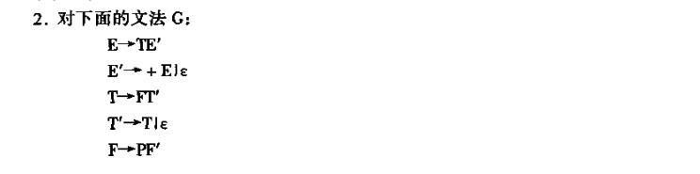

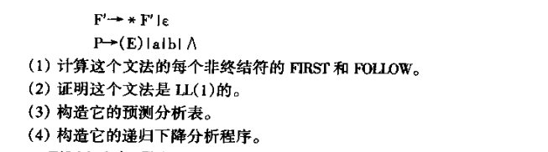

1. 解答：

FIRST(E) = {(,a,b,∧}

FIRST(E’) = {+,ε}

FIRST(T) = {(,a,b,∧}

FIRST(T’) = {(,a,b,∧,ε}

FIRST(F) = {(,a,b,∧}

FIRST(F’) = {*,ε}

FIRST(P) = {(,a,b,∧}

FOLLOW(E) = {#,)}

FOLLOW(E’) = {#,)}

FOLLOW(T) = {+,),#}

FOLLOW(T’) = {+,),#}

FOLLOW(F) = {(,a,b,∧,+,),#}

FOLLOW(F’) = {(,a,b,∧,+,),#}

FOLLOW(P) = {*,(,a,b,∧,+,),#}

1. 解答：

对于上面的产生式，

FIRST(+E) ∩ FIRST(ε) = Φ

FIRST(+E) ∩ FOLLOW(E’) = Φ

FIRST(T) ∩ FIRST(ε) = Φ

FIRST(T) ∩ FOLLOW(T’) = Φ

FIRST(*F’) ∩ FIRST(ε) = Φ

FIRST(*F’) ∩ FOLLOW(F’) = Φ

FIRST(E) ∩ FIRST(a) ∩ FIRST(b) ∩ FIRST(∧) = Φ

所以上面是LL(1)文法

1. 解答：

|  |  |  |  |  |  |  |  |  |
| --- | --- | --- | --- | --- | --- | --- | --- | --- |
|  | + | * | ( | ) | a | b | ∧ | # |
| E |  |  | E->TE’ |  | E->TE’ | E->TE’ | E->TE’ |  |
| E’ | E’->+E |  |  | E’->ε |  |  |  | E’->ε |
| T |  |  | T->FT’ |  | T->FT’ | T->FT’ | T->FT’ |  |
| T’ | T’->ε |  | T’->T | T’->ε | T’->T | T’->T | T’->T | T’->ε |
| F |  |  | F->PF’ |  | F->PF’ | F->PF’ | F->PF’ |  |
| F’ | F’->ε | F’->*F’ | F’->ε | F’->ε | F’->ε | F’->ε | F’->ε | F’->ε |
| P |  |  | P->(E) |  | P->a | P->b | P->∧ |  |

1. 解答：

P(E)

begin

if ch == ‘(’ or ch == ‘a’ or ch == ‘b’ or ch == ‘∧’

Then begin

P(T),P(E’)

end

else error

end

P(E’)

begin

if ch == ‘+’

Then begin

P(E)

end

else if ch == ‘)’and ch == ‘#’

then error

end

P(T)

begin

if ch == ‘(’ or ch == ‘a’ or ch == ‘b’ or ch == ‘∧’

Then begin

P(F),P(T’)

end

else error

end

P(T’)

begin

if ch == ‘(’ or ch == ‘a’ or ch == ‘b’ or ch == ‘∧’

Then P(T)

else if ch == ‘*’ then error;

End

P(F)

begin

if ch == ‘(’ or ch == ‘a’ or ch == ‘b’ or ch == ‘∧’

Then begin

P(P),P(F’)

end

else error

end

P(F’)

begin

if ch == ‘*’

Then P(F)

end

P(P)

begin

If ch == ‘a’ or ch == ‘b’ or ch == ‘∧’

Then next

Else if ch == ‘(’

then

begin

P(E)

if ch == ‘(’ then next

else error;

end

else error

end